UNIT III
Mobile operating system

Mobile Operating System
A mobile operating system is an operating system that helps to run other application software on mobile devices. It is the same kind of software as the famous computer operating systems like Linux and Windows, but now they are light and simple to some extent.
The operating systems found on smartphones include Symbian OS, iPhone OS, RIM's BlackBerry, Windows Mobile, Palm WebOS, Android, and Maemo. Android, WebOS, and Maemo are all derived from Linux. The iPhone OS originated from BSD and NeXTSTEP, which are related to Unix.
It combines the beauty of computer and hand use devices. It typically contains a cellular built-in modem and SIM tray for telephony and internet connections. If you buy a mobile, the manufacturer company chooses the OS for that specific device.

Mobile Computing
Mobile Computing tutorial provides basic and advanced concepts of mobile computing. In this tutorial, you will get an overview of Mobile Computing, its continuous evolution, and the future trends of this technology. Our Mobile Computing tutorial is designed for beginners and professionals.
Mobile Computing refers a technology that allows transmission of data, voice and video via a computer or any other wireless enabled device. It is free from having a connection with a fixed physical link. It facilitates the users to move from one physical location to another during communication

Introduction of Mobile Computing
Mobile Computing is a technology that provides an environment that enables users to transmit data from one device to another device without the use of any physical link or cables.
This is only because of Mobile Computing technology that you can access and transmit data from any remote locations without being present there physically. Mobile computing technology provides a vast coverage diameter for communication. It is one of the fastest and most reliable sectors of the computing technology field.
The concept of Mobile Computing can be divided into three parts:
- Mobile Communication
- Mobile Hardware
- Mobile Software

Mobile Communication
Mobile Communication specifies a framework that is responsible for the working of mobile computing technology. In this case, mobile communication refers to an infrastructure that ensures seamless and reliable communication among wireless devices. This framework ensures the consistency and reliability of communication between wireless devices. The mobile communication framework consists of communication devices such as protocols, services, bandwidth, and portals necessary to facilitate and support the stated services. These devices are responsible for delivering a smooth communication process.
Mobile communication can be divided in the following four types:
- Fixed and Wired
- Fixed and Wireless
- Mobile and Wired
- Mobile and Wireless
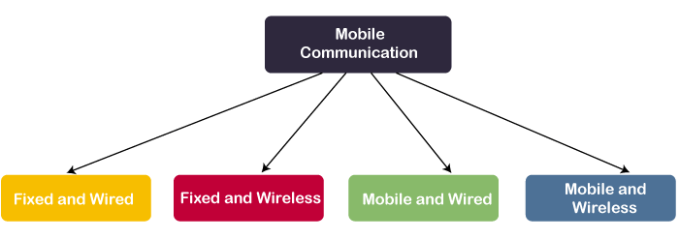
Fixed and Wired: In Fixed and Wired configuration, the devices are fixed at a position, and they are connected through a physical link to communicate with other devices.
For Example, Desktop Computer.
Fixed and Wireless: In Fixed and Wireless configuration, the devices are fixed at a position, and they are connected through a wireless link to make communication with other devices.

Mobile Hardware
Mobile hardware consists of mobile devices or device components that can be used to receive or access the service of mobility. Examples of mobile hardware can be smartphones, laptops, portable PCs, tablet PCs, Personal Digital Assistants, etc.
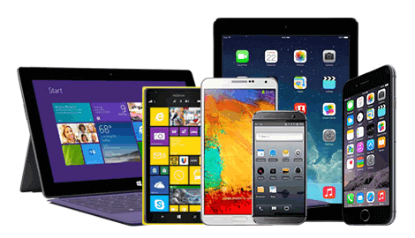
These devices are inbuilt with a receptor medium that can send and receive signals. These devices are capable of operating in full-duplex. It means they can send and receive signals at the same time. They don't have to wait until one device has finished communicating for the other device to initiate communications.

Mobile Software
Mobile software is a program that runs on mobile hardware. This is designed to deal capably with the characteristics and requirements of mobile applications. This is the operating system for the appliance of mobile devices. In other words, you can say it the heart of the mobile systems. This is an essential component that operates the mobile device.
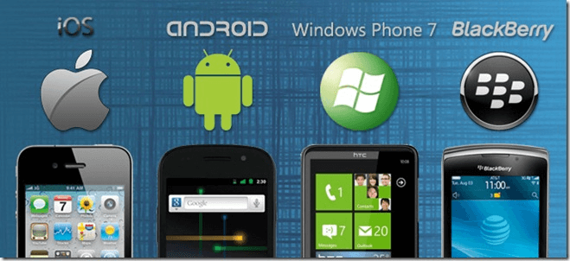
This provides portability to mobile devices, which ensures wireless communication.

Applications of Mobile Computing
Following is a list of some significant fields in which mobile computing is generally applied:
- Web or Internet access.
- Global Position System (GPS).
- Emergency services.
- Entertainment services.
- Educational services.

Functions of Operating System

An operating system is a program on which application programs are executed and acts as a communication bridge (interface) between the user and the computer hardware.
The main task an operating system carries out is the allocation of resources and services, such as the allocation of memory, devices, processors, and information. The operating system also includes programs to manage these resources, such as a traffic controller, a scheduler, memory management module, I/O programs, and a file system.
Important functions of an operating System:
- Security –
The operating system uses password protection to protect user data and similar other techniques. it also prevents unauthorized access to programs and user data.
- Control over system performance –
Monitors overall system health to help improve performance. records the response time between service requests and system response to having a complete view of the system health. This can help improve performance by providing important information needed to troubleshoot problems.
- Job accounting –
Operating system Keeps track of time and resources used by various tasks and users, this information can be used to track resource usage for a particular user or group of users.
- Error detecting aids –
The operating system constantly monitors the system to detect errors and avoid the malfunctioning of a computer system.
- Coordination between other software and users –
Operating systems also coordinate and assign interpreters, compilers, assemblers, and other software to the various users of the computer systems.
- Memory Management –
The operating system manages the Primary Memory or Main Memory. Main memory is made up of a large array of bytes or words where each byte or word is assigned a certain address. Main memory is fast storage and it can be accessed directly by the CPU. For a program to be executed, it should be first loaded in the main memory. An Operating System performs the following activities for memory management:
It keeps track of primary memory, i.e., which bytes of memory are used by which user program. The memory addresses that have already been allocated and the memory addresses of the memory that has not yet been used. In multiprogramming, the OS decides the order in which processes are granted access to memory, and for how long. It Allocates the memory to a process when the process requests it and deallocates the memory when the process has terminated or is performing an I/O operation.
- Processor Management –
In a multi-programming environment, the OS decides the order in which processes have access to the processor, and how much processing time each process has. This function of OS is called process scheduling. An Operating System performs the following activities for processor management.
Keeps track of the status of processes. The program which performs this task is known as a traffic controller. Allocates the CPU that is a processor to a process. De-allocates processor when a process is no more required.
- Device Management –
An OS manages device communication via their respective drivers. It performs the following activities for device management. Keeps track of all devices connected to the system. designates a program responsible for every device known as the Input/Output controller. Decides which process gets access to a certain device and for how long. Allocates devices in an effective and efficient way. Deallocates devices when they are no longer required.
- File Management –
A file system is organized into directories for efficient or easy navigation and usage. These directories may contain other directories and other files. An Operating System carries out the following file management activities. It keeps track of where information is stored, user access settings and status of every file, and more… These facilities are collectively known as the file system.
Time-Sharing Operating Systems
An operating system (OS) is basically a collection of software that manages computer hardware resources and provides common services for computer programs. Operating system is a crucial component of the system software in a computer system.
Time-Sharing Operating Systems is one of the important type of operating system.
Time-sharing enables many people, located at various terminals, to use a particular computer system at the same time. Multitasking or Time-Sharing Systems is a logical extension of multiprogramming. Processor’s time is shared among multiple users simultaneously is termed as time-sharing.
The main difference between Time-Sharing Systems and Multi programmed Batch Systems is that in case of Multi programmed batch systems, the objective is to maximize processor use, whereas in Time-Sharing Systems, the objective is to minimize response time.

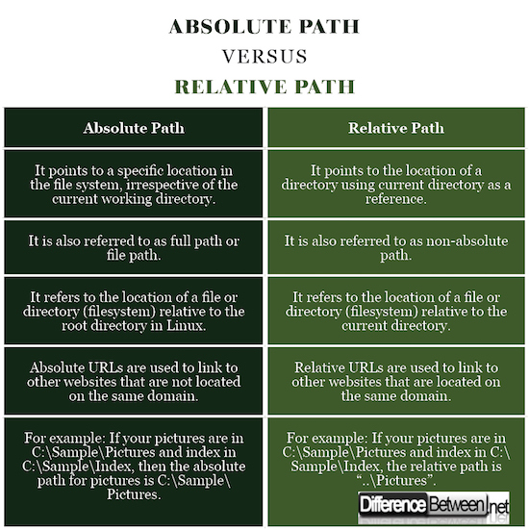

Internet
It is a worldwide/global system of interconnected computer networks. It uses the standard Internet Protocol (TCP/IP). Every computer in Internet is identified by a unique IP address. IP Address is a unique set of numbers (such as 110.22.33.114) which identifies a computer’s location.
A special computer DNS (Domain Name Server) is used to provide a name to the IP Address so that the user can locate a computer by a name. For example, a DNS server will resolve a name https://www.tutorialspoint.com to a particular IP address to uniquely identify the computer on which this website is hosted.
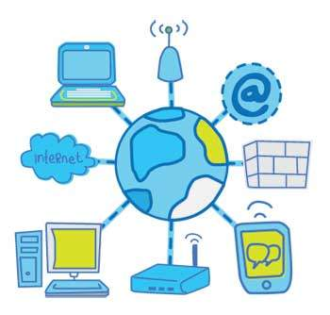
Internet is accessible to every user all over the world.

Intranet
Intranet is the system in which multiple PCs are connected to each other. PCs in intranet are not available to the world outside the intranet. Usually each organization has its own Intranet network and members/employees of that organization can access the computers in their intranet.
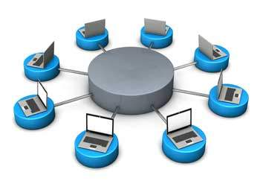
Each computer in Intranet is also identified by an IP Address which is unique among the computers in that Intranet.
One of the most famous network services is electronic mail (e-mail). The simple standard mechanism for electronic mail on the internet. The first email systems simply consisted of file transfer protocols.
But some of the limitations of this system were as follows−
- Sending a message to a group of people was inconvenient.
- Messages did not have many internet structures. So, its computer processing was complex.
- The sender never knew if the message arrived or not.
- It was not easy to hand over one's email to someone else.
- The user interface was poorly integrated.
- It was impossible to create and send messages containing a text, drawing, facsimile and voice together.

Email Architecture and Services
An e-mail system includes two subsystems as under:
- User agents
- Message transfer agents

User agents
They allow people to read message transfer agents.
They transfer the messages from the source to the destination.

Basic Functions
The E-mail system supports five basic systems, which are as follows:

Composition
The process of generating messages and answering them is called composition. The system can also support assistance with addressing and several header fields attached to each message.

Transfer
It is the process of moving messages from the sender to the recipient. This includes establishing a connection from the sender to a destination or some intermediate machine, outputting the message and releasing the connection.

Reporting
This is to tell the sender whether the message was delivered or rejected, or lost.

Displaying
It is the process of displaying incoming messages. For this purpose, simple conversation and formatting are required to be done.

Disposition
This is concerned with what the recipient does with the messages after receiving them. Some of the possibilities are as follows −
- Throw after reading
- Throw before reading
- Save messages
- Forward messages
- Process messages in some other way

Advanced Features
Some of the advanced features of Email Systems included in addition to the essential functions are as follows −
- It can be forwarding an email to a person away from his computer.
- It can create and destroy mailboxes to store incoming e-mail.
- It can inspect the contents of the mailbox, insert and delete messages from the mailboxes.
- It can send a message to a vast group of people using the mail list idea.
- It is used to provide a registered email.
- It is used for automatic notification of undelivered email.
- It is used to carbon copies.
- It is used to high priority email.
- It can make an alternative recipient

Data Mining
Data Mining is defined as the procedure of extracting information from huge sets of data. In other words, we can say that data mining is mining knowledge from data. The tutorial starts off with a basic overview and the terminologies involved in data mining and then gradually moves on to cover topics such as knowledge discovery, query language, classification and prediction, decision tree induction, cluster analysis, and how to mine the Web.

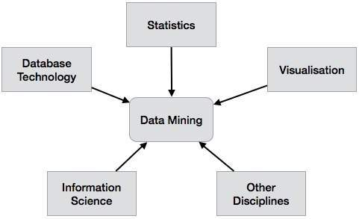

Data warehouse
A data warehouse is constructed by integrating data from multiple heterogeneous sources. It supports analytical reporting, structured and/or ad hoc queries and decision making. This tutorial adopts a step-by-step approach to explain all the necessary concepts of data warehousing.
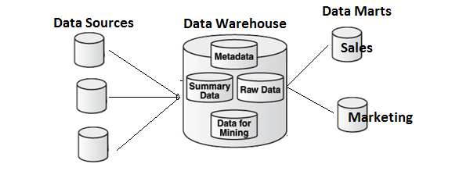
Data storage
Data storage refers to the use of recording media to retain data using computers or other devices. The most prevalent forms of data storage are file storage, block storage and object storage, with each being ideal for different purposes.

File storage
Inexpensive and simply constructed, data is stored in files and folders. This is commonly found on hard drives and means that the files look exactly the same to the hard drive as they do to the user.

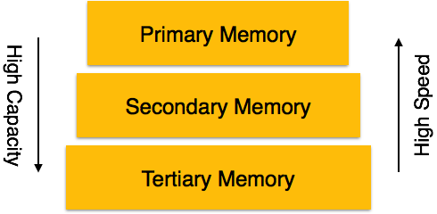
Data mining
Data mining is one of the most useful techniques that help entrepreneurs, researchers, and individuals to extract valuable information from huge sets of data. Data mining is also called Knowledge Discovery in Database (KDD). The knowledge discovery process includes Data cleaning, Data integration, Data selection, Data transformation, Data mining, Pattern evaluation, and Knowledge presentation.
Our Data mining tutorial includes all topics of Data mining such as applications, Data mining vs Machine learning, Data mining tools, Social Media Data mining, Data mining techniques, Clustering in data mining, Challenges in Data mining, etc.

UNIT IV
Networking
A network is two or more computers (or other electronic devices) that are connected together, usually by cables or Wi-Fi. Some computer networks will have a server. A server is a powerful computer that often acts as a central hub for services in a network, eg emails, internet access and file storage.
Types of Computer Networks
- Personal Area Network (PAN)
- Local Area Network (LAN)
- Wide Area Network (WAN)
- Metropolitan Area Network (MAN)
Personal Area Network (PAN) :
PAN is the most basic type of computer network. This network is restrained to a single person, that is, communication between the computer devices is centered only to an individual’s work space. PAN offers a network range of 10 meters from a person to the device providing communication.
Examples of PAN are USB, computer, phone, tablet, printer, PDA, etc.
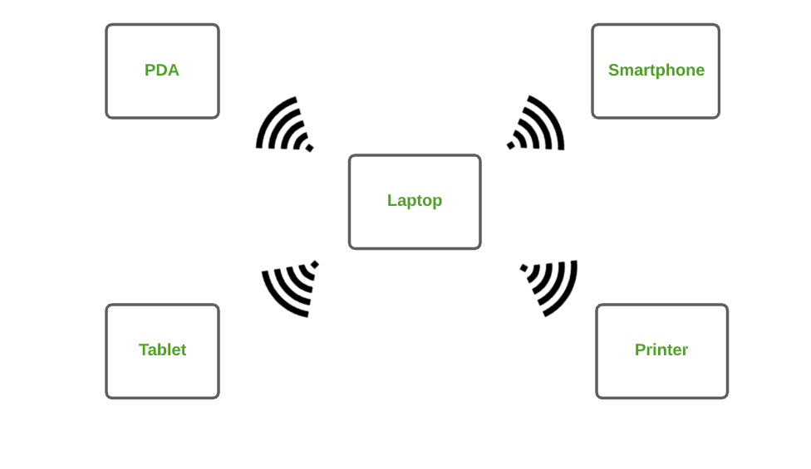
2. Local Area Network (LAN) :
LAN is the most frequently used network. A LAN is a computer network that connects computers together through a common communication path, contained within a limited area, that is, locally. A LAN encompasses two or more computers connected over a server. The two important technologies involved in this network are Ethernet and Wi-fi.
Examples of LAN are networking in a home, school, library, laboratory, college, office, etc.
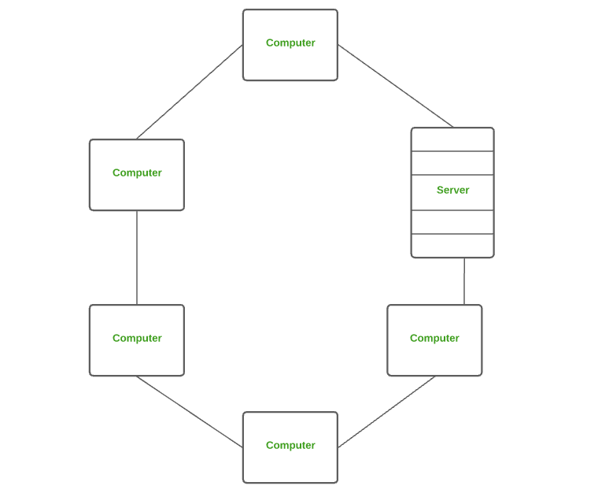
3. Wide Area Network (WAN) :
WAN is a type of computer network that connects computers over a large geographical distance through a shared communication path. It is not restrained to a single location but extends over many locations. WAN can also be defined as a group of local area networks that communicate with each other.
The most common example of WAN is the Internet.
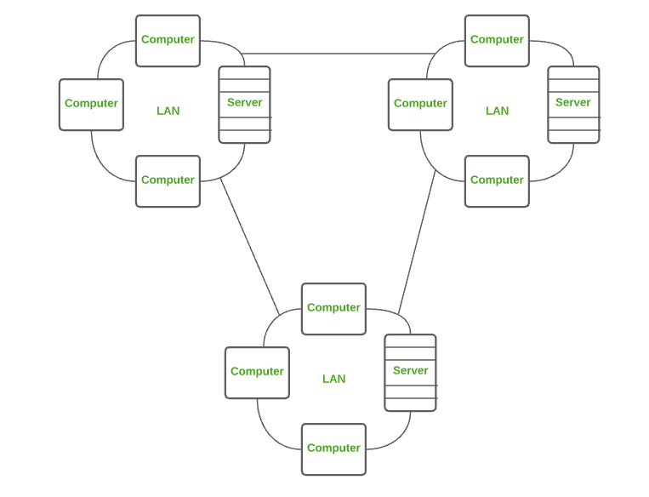
4.Wireless Local Area Network (WLAN) :
WLAN is a type of computer network that acts as a local area network but makes use of wireless network technology like Wi-Fi. This network doesn’t allow devices to communicate over physical cables like in LAN but allows devices to communicate wirelessly.
The most common example of WLAN is Wi-Fi.
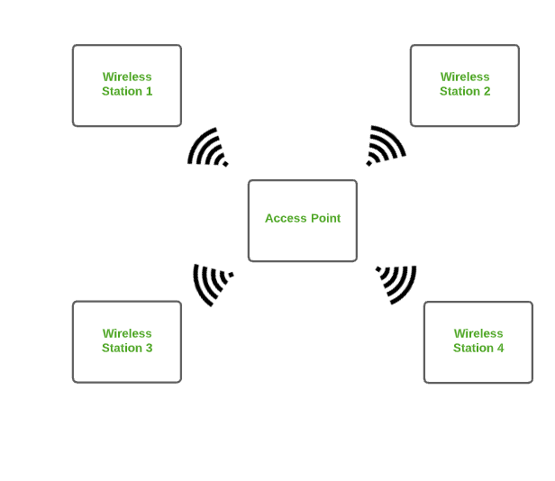
Metropolitan Area Network (MAN) :
A MAN is larger than a LAN but smaller than a WAN. This is the type of computer network that connects computers over a geographical distance through a shared communication path over a city, town or metropolitan area.
Examples of MAN are networking in towns, cities, a single large city, large area within multiple buildings, etc.
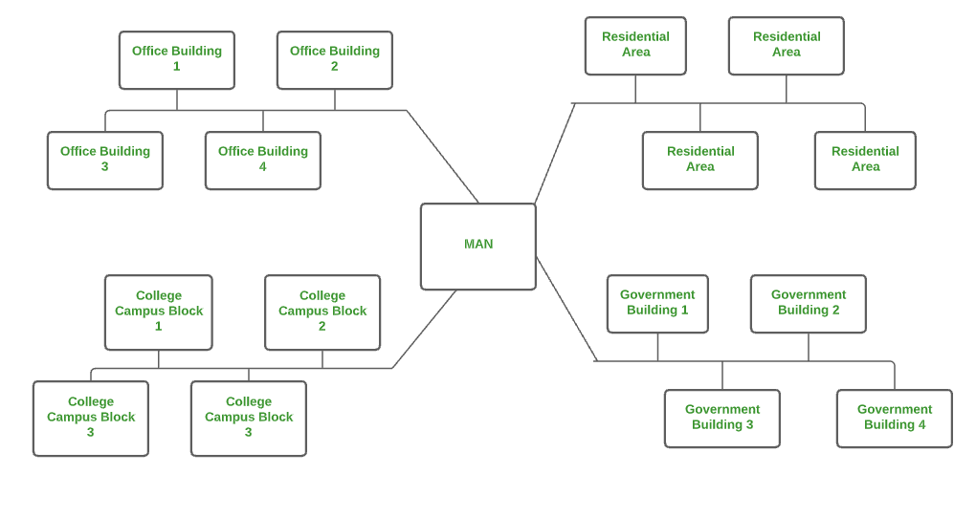
Transmission Control Protocol
TCP (Transmission Control Protocol) is one of the main protocols of the Internet protocol suite. It lies between the Application and Network Layers which are used in providing reliable delivery services. It is a connection-oriented protocol for communications that helps in the exchange of messages between different devices over a network. The Internet Protocol (IP), which establishes the technique for sending data packets between computers, works with TCP.
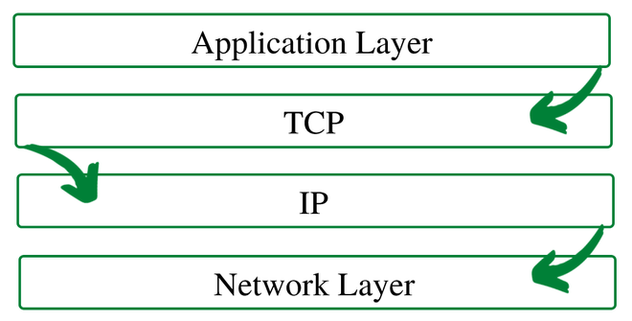
TCP/IP Layer

- Application Layer: The application layer makes sure that the data from the sending end is received in a format that is acceptable and supported at the receiving end.
- Transport Layer: The transport layer is responsible for the smooth transmission of data from one end to the other. It is also responsible for reliable connectivity, error recovery, and flow control of the data.
- Internet Layer: This Internet Layer moves packets from source to destination by connecting independent networks.
- Network Access Layer: The Network Access Layer sees how a computer connects to a network.
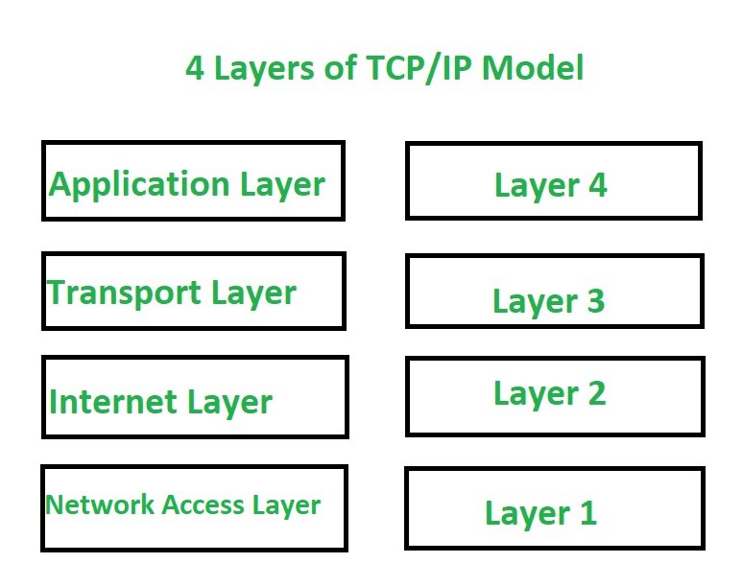
Data processing and File Processing

File based system | Database system
1. The data and program are inter- dependent. | 1. The data and program are independent of each other.
2. File-based system caused data redundancy. The data may be duplicated in different files | 2. Database system control data redundancy. The data appeared only once in the system.
3. File –based system caused data inconsistency. The data in different files may be different that cause data inconsistency. | 3. In database system data always consistent. Because data appeared only once.
4. The data cannot be shared because data is distributed in different files. | 4. In database data is easily shared because data is stored at one place.
5. In file based system data is widely spread. Due to this reason file based system provides poor security. | 5. It provides many methods to maintain data security in the database.
6. File based system does not provide consistency constrains. | 6. Database system provides a different consistency constrains to maintain data integrity in the system.
7. File based system is less complex system. | 7. Database system is very complex system.
8. The cost of file processing system is less then database system. | 8. The cost of database system is much more than a file processing system.
9. File based system takes much space in the system, and memory is wasted in this approach. | 9. Database approach store data more efficiently it takes less space in the system and memory is not wasted.
10. To generate different report to take a crucial decision is very difficult in file based system. | 10. The report can be generated very easily in required format in database system. Because data in database is stored in an organized manner. And easily retrieve to generate different report.
11. File based system does not provide concurrency facility. | 11. Database system provides concurrency facility.
12. File based system does not provide data atomicity functionality. | 12. Database system provides data atomicity functionality.
13. The cost of file processing system is less than database system. | 13. The cost of database system is more than file processing system.
14. It is difficult to maintain as it provides less controlling facility. | 14. Database provides many facility to maintain program.
15. If one application fail it does not affects other files in system. | 15. If database fail it affects all application that dependent on database
16. Hardware cost is less than database system | 16. Hardware cost is high in database than file system.

Difference between Multiprocessing and Multiprogramming
S.No. | Multiprocessing | Multiprogramming
1. | The availability of more than one processor per system, that can execute several set of instructions in parallel is known as multiprocessing. | The concurrent application of more than one program in the main memory is known as multiprogramming.
2. | The number of CPU is more than one. | The number of CPU is one.
3. | It takes less time for job processing. | It takes more time to process the jobs.
4. | In this, more than one process can be executed at a time. | In this, one process can be executed at a time.
5. | It is economical. | It is economical.
6. | The number of users is can be one or more than one. | The number of users is one at a time.
7. | Throughput is maximum. | Throughput is less.
8. | Its efficiency is maximum. | Its efficiency is Less.
System Architecture
A system architecture is a representation of a system in which there is a mapping of functionality onto hardware and software components, a mapping of the software architecture onto the hardware architecture, and human interaction with these components.
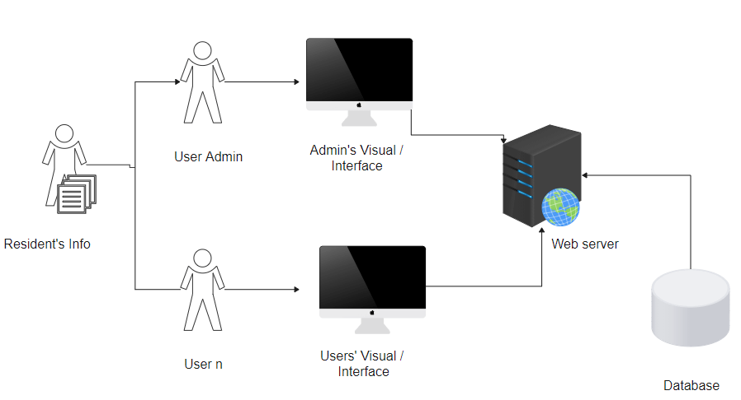

ISP Types
ISPs can broadly be classified into six categories as shown in the following diagram:
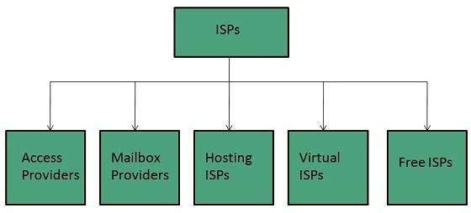

Access providers
They provide access to internet through telephone lines, cable wi-fi or fiber optics.

Mailbox Provider
Such providers offer mailbox hosting services.

Hosting ISPs
Hosting ISPs offers e-mail, and other web hosting services such as virtual machines, clouds etc.

Virtual ISPs
Such ISPs offer internet access via other ISP services.

Free ISPs
Free ISPs do not charge for internet services.

Connection Types
There exist several ways to connect to the internet. Following are these connection types available:
- Dial-up Connection
- ISDN
- DSL
- Cable TV Internet connections
- Satellite Internet connections
- Wireless Internet Connections

Dial-up Connection
Dial-up connection uses telephone line to connect PC to the internet. It requires a modem to setup dial-up connection. This modem works as an interface between PC and the telephone line.
There is also a communication program that instructs the modem to make a call to specific number provided by an ISP.
Dial-up connection uses either of the following protocols:
- Serial Line Internet Protocol (SLIP)
- Point to Point Protocol (PPP)
The following diagram shows the accessing internet using modem:
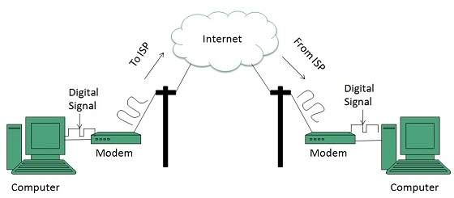

ISDN
ISDN is acronym of Integrated Services Digital Network. It establishes the connection using the phone lines which carry digital signals instead of analog signals.
There are two techniques to deliver ISDN services:
- Basic Rate Interface (BRI)
- Primary Rate Interface (PRI)

Requirements of e-payment systems
Requirements
Important characteristics for an Internet payment system include security, reliability, scalability, anonymity, acceptability, customer base, flexibility, convertibility, efficiency, ease of integration with applications, and ease of use. Some of these characteristics, like anonymity, are more important in some communities, or for certain kinds of transactions, than they are in other communities. These characteristics are presented for discussion and comparison. The NetCheque and NetCash systems meet some of these characteristics better than other systems, but make trade- offs with respect to some of the other characteristics.

Security
Since payments involve actual money, payment systems will be a prime target for criminals. Since Internet services are provided today on networks that are relatively open, the infrastructure supporting electronic commerce must be usable and resistant to attack in an environment where eavesdropping and modification of messages is easy.
Reliability

As more commerce is conducted over the Internet, the smooth running of the economy will come to depend on the availability of the payment infrastructure, making it a target of attack for vandals. Whether the result of an attack by vandals or simply poor design, an interruption in the availability of the infrastructure would be catastrophic. For this reason, the infrastructure must be highly available and should avoid presenting a single point of failure.
Scalability
As commercial use of the Internet grows, the demands placed on payment servers will grow too. The payment infrastructure as a whole must be able to handle the addition of users and merchants without suffering a noticeable loss of performance. The existence of central servers through which all transactions must be processed will limit the scale of the system. The payment infrastructure must support multiple servers, distributed across the network.
Anonymity
For some transactions, the identity of the parties to the transaction should be protected; it should not be possible to monitor an individual's spending patterns, nor determine one's source of income. An individual is traceable in traditional payment systems such as checks and credit cards. Where anonymity is important, the cost of tracking a transaction should outweigh the value of the information that can be obtained by doing so.
Acceptability
The usefulness of a payment mechanisms is dependent upon what one can buy with it. Thus, a payment instrument must be accepted widely. Where payment mechanisms are supported by multiple servers, users of one server must be able to transact business with users of other servers.
Customer base
The acceptability of a payment mechanism is affected by the size of the customer base, i.e. the number of users able to make payments using the mechanism. Merchants want to sell products, and without a large enough base of customers using a payment mechanism, it is often not worth the extra effort for a merchant to accept the mechanism.
Flexibility

Alternative forms of payment are needed, depending on the guarantees needed by the parties to a transaction, the timing of the payment itself, requirements for auditability, performance requirements, and the amount of the payment. The payment infrastructure should support several payment methods including instruments analogous to credit cards, personal checks, cashier's checks, and even anonymous electronic cash. These instruments should be integrated into a common framework.
Convertibility

Users of the Internet will select financial instruments that best suit their needs for a given transaction. It is likely that several forms of payment will emerge, providing different tradeoffs with respect to the characteristics just described. In such an environment it is important that funds represented by one mechanism be easily convertible into funds represented by others.
Efficiency
Royalties for access to information may generate frequent payments for small amounts. Applications must be able to make these "micropayments" without noticeable performance degradation. The cost per transaction of using the infrastructure must be small enough that it is insignificant even for transaction amounts on the order of pennies.
Ease of integration
Applications must be modified to use the payment infrastructure in order to make a payment service available to users. Ideally, a common API should be used so that the integration is not specific to one kind of payment instrument. Support for payment should be integrated into request-response protocols on which applications are built so that a basic level of service is available to higher level applications without significant modification.
Ease of use
Users should not be constantly interrupted to provide payment information and most payments should occur automatically. However, users should be able to limit their losses. Payments beyond a certain threshold should require approval. Users should be able to monitor their spending without going out of their way to do so.

How to book train ticket online; step by step guide
Step 1: Visit the IRCTC e-ticketing website: www.irctc.co.in.
Step 2: Login to the IRCTC website by using user id, password.
Step 3: You can either login with OTP facility or by entering the captcha code. If opting the OTP facility, enter the One Time Password (OTP) sent on the registered mobile number to log in.
Step 4: Fill the railway stations between which you wish to travel, ‘source station’ and ‘destination station’ on the ‘Book Your Ticket’ on the homepage of the IRCTC website.
Step 5: Enter the date of journey and class of travel.
Step 6: Click on ‘Find Trains’.
Step 7: The list of trains available on the selected route will be shown.
Step 8: Click on ‘check availability and fare’ to check the seat availability and fare of the selected class, sleeper class, 3 tier, 2 tier, 1 AC, Chair Car, Executive Car, etc.
Step 9: Select the train with which you want to travel, subject to the availability of the train tickets, and click on ‘Book Now’.
Step 10: Confirm train ticket booking by clicking on ‘Ok’ on the new dialogue box.
Step 11: Enter passenger details such as name, age, gender, food choice, seat preference, mobile number, preferred coach id (if any). Enter the details of the child, if travelling with children below 5 years of age.
Step 12: Enter the verification code and click on ‘Continue Booking’.
Step 13: Click on ‘Continue Booking’ again on the review booking page.
Step 14: Select the payment method from the options available such as credit card, debit card, net banking, mobile wallet and pay the required amount on payment window.

Discuss about online booking systems in any one domain.

Rate Plans
An online booking system must be able to deal with multiple scenarios for any given stay. You should be able to set multiple conditional rates for a room, or a property, for any given date range. These conditional rates should include:
- Rates based on time before arrival (Early or Late Bookings)
- Occupancy Based (Number of people)
- Length-of-stay based rates (longer you stay, cheaper it is)
- Add ons (Activities, Optional Extras, etc.)
- Discounts (Voucher or Codes)
Yield Manager, or Automated Rates, are great for larger operations but if you are running a small operation, they might not be as useful as you may think. However, don’t be fooled!! Automated rates do not happen on ttheir own, as you still have to set rates, plus conditions that the system should apply to calculate the rate at any given time. It is not a magic!

2. Channel Management
These days it is impossible for any hospitality business to get away from OTAs (Online Travel Agencies or Channels) such as Booking.com, Expedia, AirBnB, Homeaway, etc.
The chances are you will have to sell via 3rd parties (portals/OTA), therefore your system should be able to manage inventory, bookings, and ideally rates by linking up to external databases and booking systems. This is very important for Hotels, B&Bs, and Vacation Rental Properties regardless of the size of the operation.
If your channel inventory and your real inventory are not synchronised, there is a high chance of overbooking and embarrassing conversations, as well as poor reviews. These could also cost dearly as most portals and booking agencies ask you to commit to finding an equivalent room for their guests at your cost.

3. Guest Management
Customer experience has become the key differentiating factor in hospitality sector. Remember your customer experience starts from when they begin their journey through your website, reservation process, and right up to the moment they leave your establishment.
This means you need to communicate effectively from the moment they make a reservation. This means, your booking system is an integral part of customer experience. Automation in the process enables you to predict requirements, anticipate, and act. From reminders for payment, to providing directions, to advice on local facilities (car rental, restaurants, parking, etc.), is all about making the holiday an enjoyable experience rather than a “Challenge Tour”.
Your booking system should be able to take care of this for you, and unburden your staff so that they can concentrate on providing service to the guests that are at the premises.

4. Payment Processing
Online booking system should be capable of handling payments. Common payment methods such as PayPal, Stripe, Authorize.net, etc., should be built in or at least be easy to integrate.
Online payments do have additional costs, so beware of commission and transaction charges. Your system should be able to integrate with your credit card company’s gateway. However, these are typcially not click-and-go as each bank has their own Gateway and API. You may also have to comply with the credit card company’s requirements such as SSL certification, refund policy, etc. Make sure you factor these costs in, or ask your vendor about the options they can offer you to reduce or mitigate some of these costs.
Additionally, the system should allow you to choose how to offer deals based on payment method. For example, non-refundable rates which payment is taken upfront, Deposit Only Rates, No Deposit Rates or No Cancellation rates that all have different payment options.

5. House Keeping
The online booking system should be able to handle room status, so that you can produce lists for housekeeping and maintenance.
This does require internal discipline, as staff need to be trained to use the system effectively, but the upside is better visibility of any potential issues with rooms, and ultimately preventing customer complaints.

6. Billing
Whilst most larger hotels have their own billing systems, most smaller B&Bs and boutique hotels do not have a dedicated accounting packages.
For smaller operations, your booking system needs to be able to produce accurate, itemised, and professional looking invoices.
For larger operations, your booking system should be able to integrate with your accounting system using their respective API. Make sure your accounting system does have an API for the booking system to connect to, but also check if there is any licensing costs. Most booking systems offer their API at no cost, but you do need to pay for it to be integrated with your accounting system.

Summary
There are many options available for hospitality businesses looking for online booking system. The key in selection process is understanding your own needs clearly, and asking the right questions. Do not allow yourself to be distracted by clever whiz-bang aesthetic design, as they do not help with customer satisfaction, nor would they make your life any easier. Focus on functionality and whether the system is right for the way you operate.
Find out the true cost and not just the headline price. Costs include website integration, payment gateway integration, management time, and reliability.
We offer a range of support services for Small and Large hotels including fully featured Web Hosting and Online Booking Systems. We also offer a fully managed services for both Web Hosting and Online Reservation Systems.

